Subject-by-Subject Organizational Sequence

- Introduction

- Some common stereotypes related to men

- Filthy
1.
2.
- Lazy
1.
2.
- Insensitive
1.
2.

- The reality

- Clean
1.
2.
- Active
1.
2.

- Sensitive
1.
2.

- Conclusion

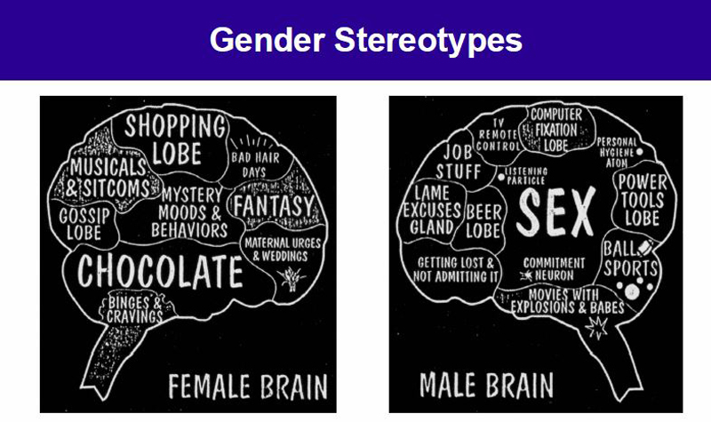

Point-by-Point Organizational Sequence

- Introduction

- Driving habits

- Poor driving skills (stereotype)
1.
2.
- Excellent driving skills (reality)
1.
2.

- Adherence to the latest fashions

- Slaves to fashion (stereotype)
1.
2.
- Not slaves to fashion (reality)
1.
2.

- Level of emotion

- High levels of emotion (stereotype)
1.
2.
- Low levels of emotion (reality)
1.
2.

- Conclusion

